
Symbiosis Institute of Technology, Pune
CSE- Academic Year 2026-27
Java Programming – Lab Batch 2025-29
Lab Assignment No.: 7
Name of Student | Akshit Gawade
PRN No. | 25070122029
Batch | 2025-2029
Class | A1
Academic Year & Semester | Second Year  Semester III
Date of Submission | 11/7/2026
Title of Assignment: | Implement a Java program to demonstrate inheritance and interfaces using suitable real-world examples.
Theory | Inheritance allows one class to acquire the properties and methods of another class, promoting code reuse and reducing redundancy. Java supports single inheritance through the extends keyword. Interfaces define a contract that implementing classes must follow, enabling abstraction and multiple inheritance of type. Together, inheritance and interfaces support polymorphism and modular software development. They are fundamental concepts of object-oriented programming
Program Code | - 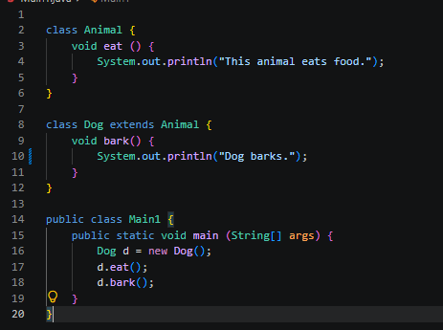  2.  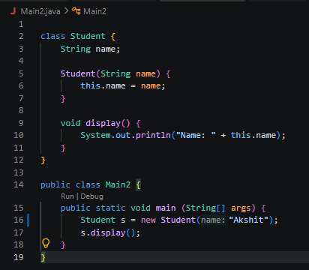
Output Screenshots | 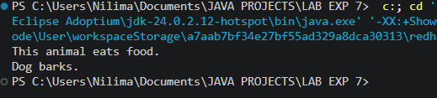  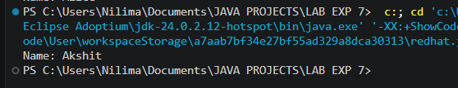
Exercise Qns | - Create a Shape application where Circle and Rectangle inherit from Shape and calculate area.  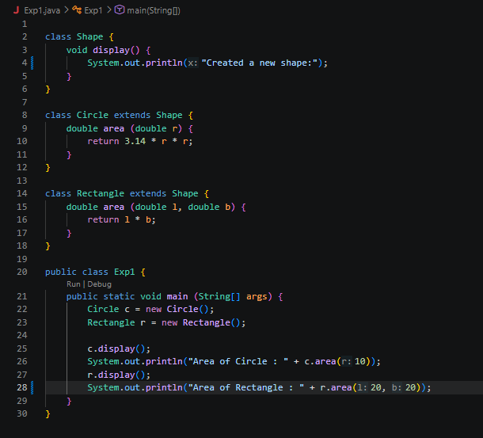  - Develop a E-Commerce Product System where electronic, clothing, and grocery products inherit common properties and implement product interfaces.  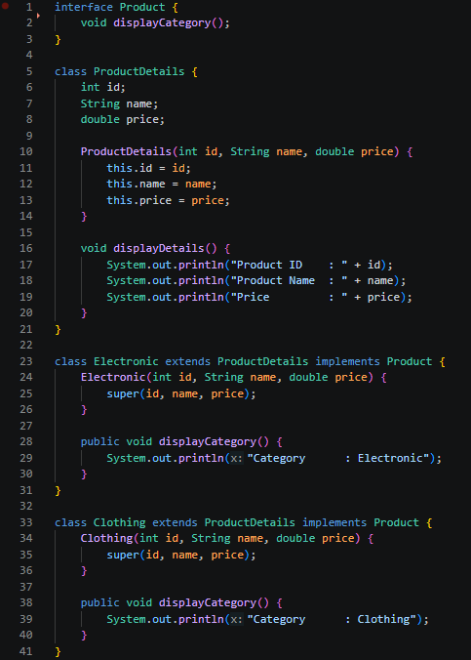  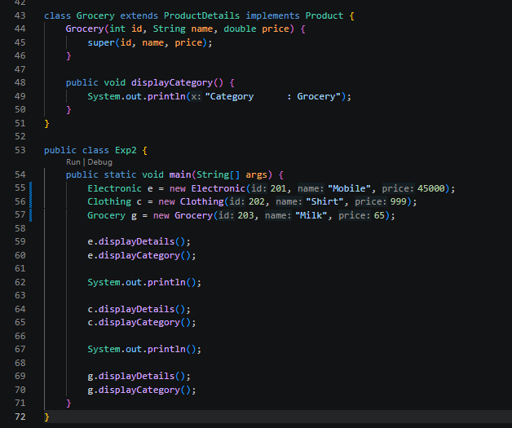
Output Screenshots | 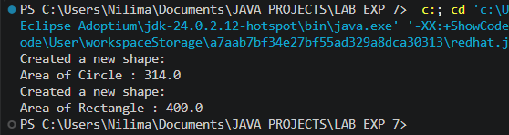  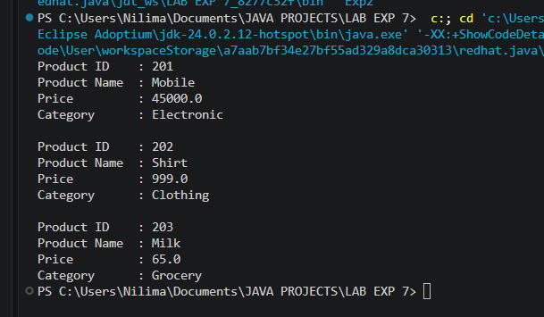
Conclusion | In this experiment, we implemented the concepts of inheritance and interfaces. We learnt the use of keyword extends and implements.

